https://www.javatpoint.com/java-tutorial
Platform Independent
Java code is compiled by the compiler and converted into bytecode. This bytecode is a platform-independent code because it can be run on multiple platforms. (Windows, Linux, Mac/OS, etc.)
i.e., Write Once and Run Anywhere (WORA).
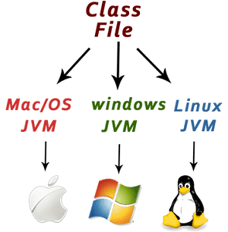

First Java Program.
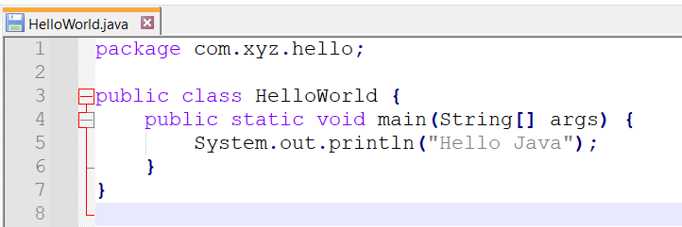
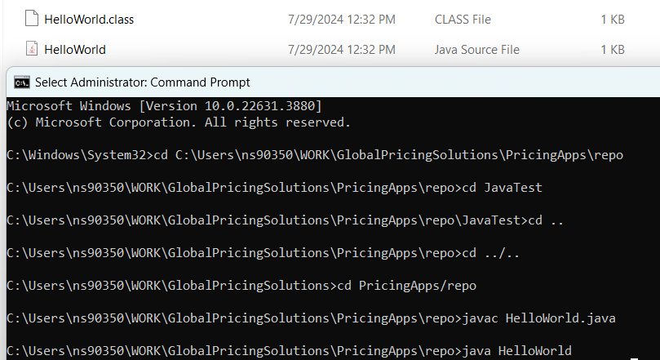

Q) Can you have multiple classes in a java source file?
Yes.
Example
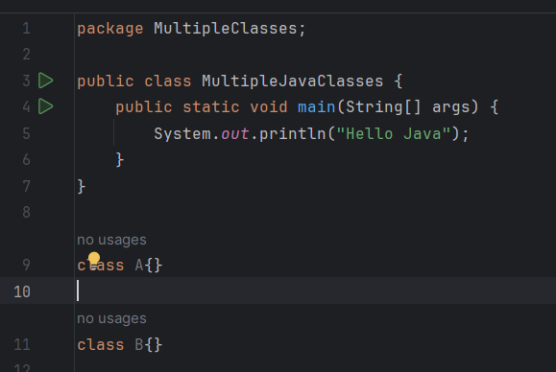
javac MultipleJavaClasses.java
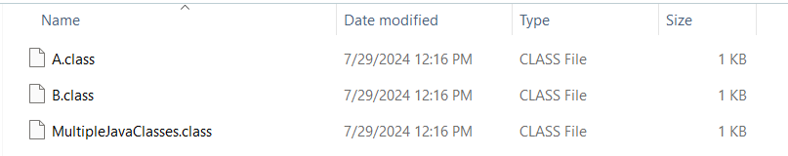

Explanation of public static void main(String[] args) in Java
- public: Access Modifier: This keyword is an access modifier that makes the main method accessible from anywhere. It is necessary because the Java Virtual Machine (JVM) needs to call this method to start the program.
- static: Class Method: The static keyword means that the method belongs to the class, not to a specific instance of the class. This allows the JVM to call the main method without creating an instance of the class.
- void: Return Type: This keyword indicates that the method does not return any value.
- main: Method Name: This is the name of the method that the JVM looks for as the entry point of the program. It is a special method in Java.
- String[] args: Parameter: This is an array of String objects that the method receives as an argument. It allows the program to accept command-line arguments. Each element in the array corresponds to a command-line argument passed to the program.
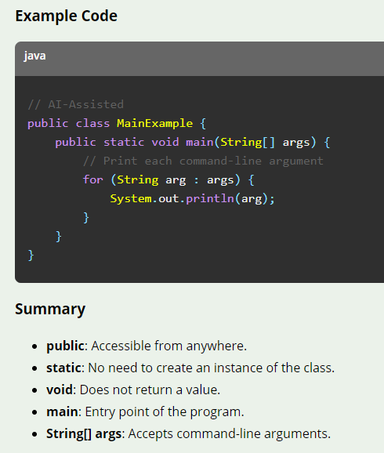

https://www.javatpoint.com/how-to-set-path-in-java
Temporary path setup
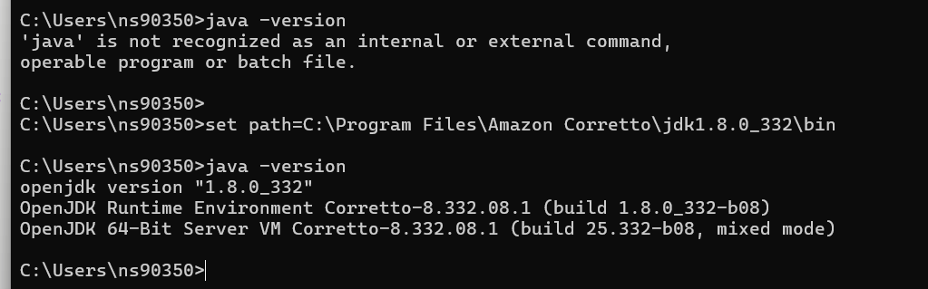
Permanent Path Setup in environment Variable
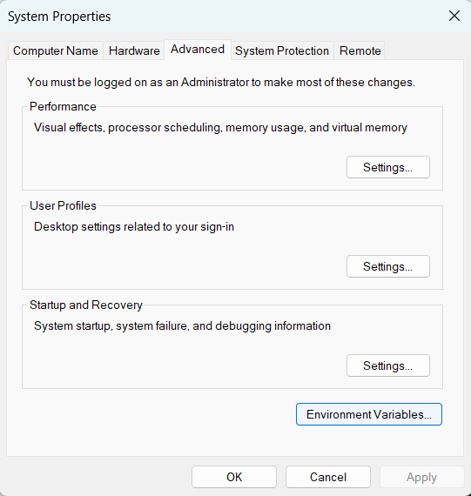
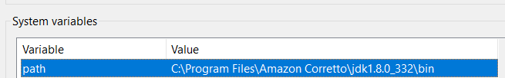

High-Level Language
- Definition: High-level languages are programming languages that are designed to be easy for humans to read and write. They abstract away most of the hardware details of the computer, allowing developers to focus on problem-solving and logic.
- Examples: Java, Python, C++, JavaScript.
- Characteristics:
  - Easy to read and write.
  - Platform-independent (mostly).
  - Requires a compiler or interpreter to translate into machine code.
  - Provides strong abstraction from hardware.
Intermediate-Level Language
- Definition: Intermediate-level languages, often referred to as assembly languages, sit between high-level languages and machine languages. They provide a closer representation of machine code but still include some level of abstraction.
- Examples: Byte Code, Assembly language.
- Characteristics:
  - Closer to machine code but more readable than binary.
  - Requires an assembler to convert into machine code.
  - Often used for system programming and performance-critical applications.
  - Provides more control over hardware compared to high-level languages.
Machine/Low-Level Language
- Definition: Machine languages are the lowest level of programming languages, consisting of binary code that the computer's CPU can execute directly. They are specific to a particular type of processor.
- Examples: Binary code, hexadecimal code.
- Characteristics:
  - Directly executed by the CPU.
  - Hardware-specific.
  - Difficult to read and write for humans.
  - Provides the highest level of control over hardware.
Summary
- High-Level Language: Easy to read and write, abstracted from hardware, requires compilation or interpretation.
- Intermediate-Level Language: Closer to machine code, requires assembly, used for system-level programming.
- Machine/Low-Level Language: Directly executed by the CPU, hardware-specific, difficult for humans to read and write.

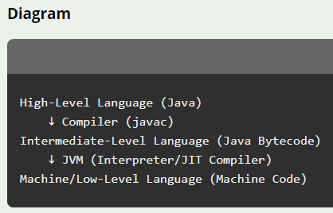 | 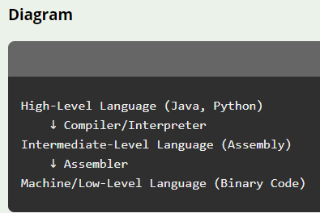

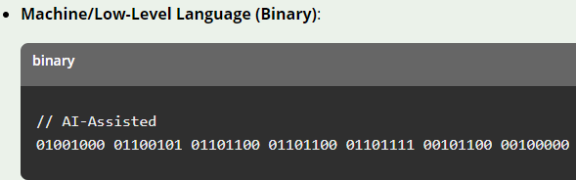

Difference between JDK, JRE, and JVM
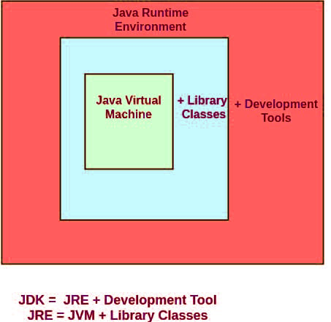
- JDK (Java Development Kit):
  - Purpose: The JDK is a software development kit used to develop Java applications. It includes the JRE, an interpreter/loader (Java), a compiler (javac), an archiver (jar), a documentation generator (Javadoc), and other tools needed for Java development.
  - Components:
    - JRE (Java Runtime Environment)
    - Development tools (compiler, debugger, etc.)
  - Use Case: Required for developing and compiling Java programs.
- JRE (Java Runtime Environment):
  - Purpose: The JRE provides the libraries, Java Virtual Machine (JVM), and other components to run applications written in Java. It does not include development tools like compilers or debuggers.
  - Components:
    - JVM (Java Virtual Machine)
    - Core libraries and other files
  - Use Case: Required for running Java applications.
- JVM (Java Virtual Machine):
  - Purpose: The JVM is an abstract machine that enables your computer to run a Java program. It converts Java bytecode into machine code that can be executed by the computer's CPU.
  - Components:
    - Class Loader
    - Bytecode Verifier
    - Interpreter
    - JIT (Just-In-Time) compiler
  - Use Case: Required for executing Java bytecode.
Summary
- JDK: Development kit for Java, includes JRE and development tools.
- JRE: Runtime environment for running Java applications, includes JVM.
- JVM: Abstract machine for executing Java bytecode – which convert byte code to low level language which then CPU execute

Note: In the latest versions of Java, particularly starting from Java 9, JDK & JRE combined in one package for Simplification.
Meaning you do not see separate JRE from JAVA 9.

Java 8 – JRE present | Java17 – No JRE
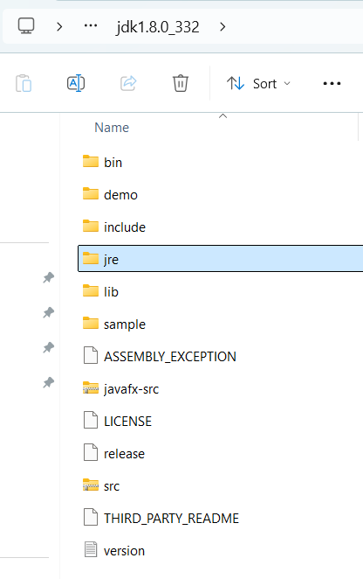 | 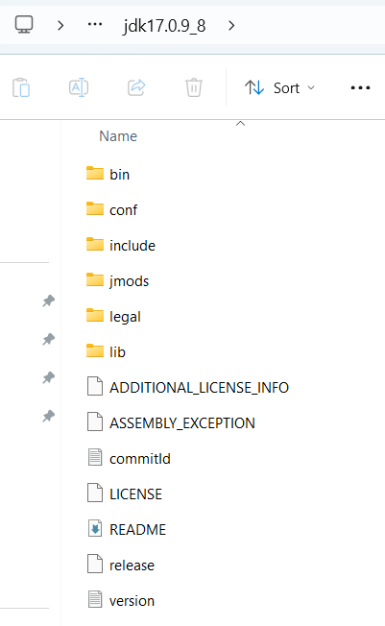

Java Virtual Machine (JVM)
Definition
The Java Virtual Machine (JVM) is an abstract computing machine that enables a computer to run a Java program. It provides a runtime environment in which Java bytecode can be executed.

Summary: java HelloWorld
- Class Loader: Loads and links class files.
- Bytecode Interpreter: Executes Java bytecode.
- JIT Compilation: Optimizes performance by compiling bytecode to native code at runtime.
- Memory Management: Manages heap and stack memory and performs garbage collection.
- Security: Ensures safe execution through bytecode verification and sandboxing.
- Platform Independence: Allows Java programs to run on any device with a JVM.
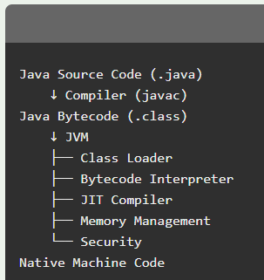

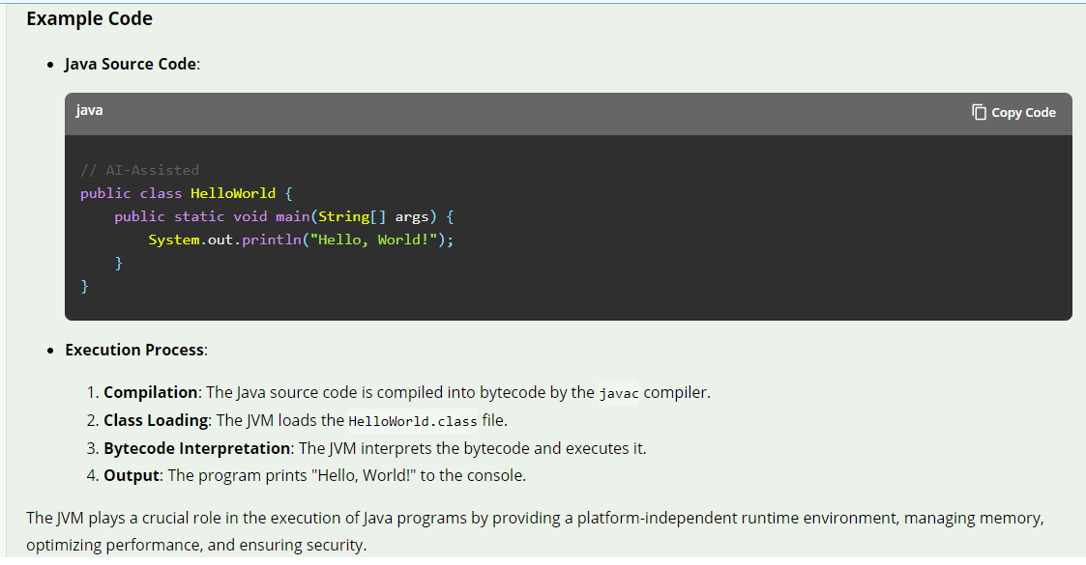

Java Operator Precedence

https://www.javatpoint.com/operators-in-java

Operator Type | Category | Precedence
Unary | postfix | expr++ expr--
 | prefix | ++expr --expr +expr -expr ~ !
Arithmetic | multiplicative | * / %
 | additive | + -
Shift(**) | shift | << >> >>>
Relational | comparison | < > <= >= instanceof
 | equality | == !=
Bitwise(**) | bitwise AND | &
 | bitwise exclusive OR | ^
 | bitwise inclusive OR | |
Logical | logical AND | &&
 | logical OR | ||
Ternary | ternary | ? :
Assignment | assignment | = += -= *= /= %= &= ^= |= <<= >>= >>>=

Read about Java Keywords

https://www.javatpoint.com/java-keywords

String & Its Programs -
https://medium.com/geekculture/all-about-string-in-java-51ba9e46181a
https://www.javatpoint.com/java-string

Why string is immutable?

Array & Its Programs

https://medium.com/@AlexanderObregon/a-guide-to-object-oriented-programming-in-java-89dc4544837f#:~:text=The%20four%20fundamental%20principles%20of,hidden%20from%20the%20outside%20view.

https://medium.com/edureka/object-oriented-programming-b29cfd50eca0

https://medium.com/@piyushjunonkar143/oops-concepts-in-java-9a2a33782a2a

https://medium.com/javarevisited/explaining-object-oriented-concept-in-java-4e61dc5b0a15

